UU College of Social Justice
by the Numbers
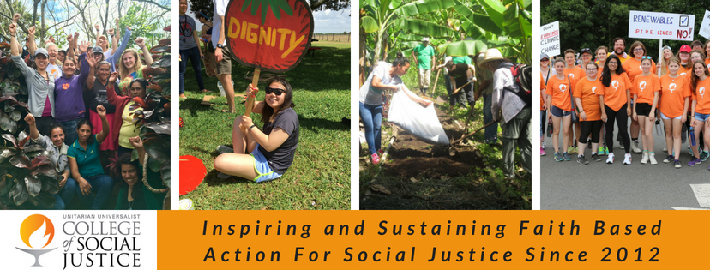

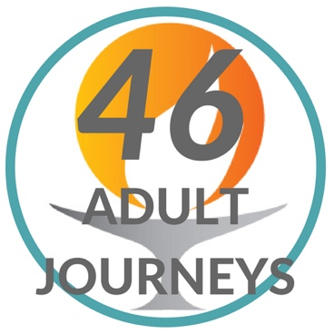

Since June 2012, the UU College of Social Justice has run 46 immersion journeys for adults with a total of 543 participants (95 of whom were ministers, religious educators or seminary students).

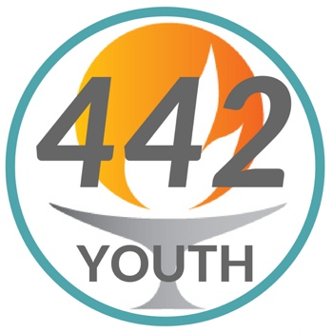

Through 22 week-long youth focused immersion learning journeys and training programs as well as three one-day offerings during general assembly, 442 youth have experienced how Unitarian Universalism can inform their work for justice.
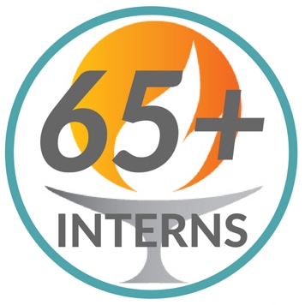

We have placed 65 interns and counting in summer-long immersion internships in over 15 different grassroots justice organizations.

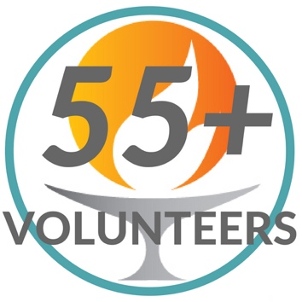

We have sent 55 skilled volunteers to placements with partner organizations for between one to 8 weeks. Most of those placements were lawyers and Spanish speakers working with RAICES in San Antonio, Texas to help the women and children detained in Karnes.

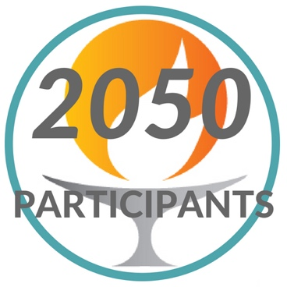

Total participants across our programs totals 2,050. This number does not include collaborative training programs like the UU-UNO Spring Seminar and the Goldmine Youth leadership program which extend our reach even further!

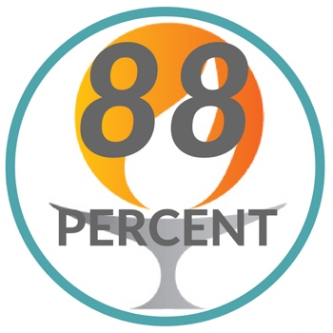

Of the participants who participated in our impact assessment, 88% said that, as a result of their journey, they have a deeper sense of the connection between their faith and the role it can play in social justice.

Participants – both those who came as individuals and those travelling in a congregational group – came from 279 congregations representing nearly every state in the country.

