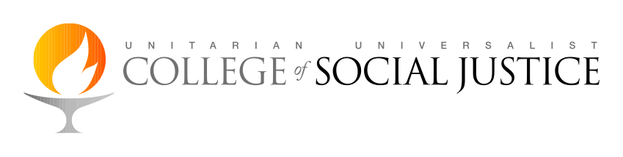
Resources for Immersion Journey, Guardians of the River

I. Film: Background on U.S. imperialism in the region: Harvest of Empire is a full-length film, 1.5 hours in length. It offers an important historic review of the way the United States has engaged with Latin America. https://www.amazon.com/Harvest-Empire-Juan-Gonzalez/dp/B00DCYVEP6/ref=sr_1_2?ie=UTF8&qid=1407856877&sr=8-2&keywords=harvest+of+empire

II. Essays: The following essays have been carefully chosen to illuminate several dynamics within current Nicaragua which we’ll explore on this journey. They are listed below according to topic; they are also embedded in the Study Guide, along with reflection questions.

1. Background on the political situation in Nicaragua: This chapter from Living In the Shadow of the Eagle concerns the Somoza era and the revolution that overthrew it: http://uucsj.org/wp-content/uploads/2016/03/Living-in-The-Shadow-of-the-Eagle-CH3.pdf
This recent essay in Envio, magazine of the Universidad Centroamericana (UCA), offers arguments from a former Sandinista revolutionary for why the Ortega government (still nominally Sandinista) should be called a dictatorship: http://www.envio.org.ni/articulo/5250

2. Environmental Justice struggles: This brief article gives an overview of the environmental challenges facing the country. It was submitted by Centro Humboldt, a respected environmental NGO and one we will meet while in country: http://www.envio.org.ni/articulo/5186

If you have not already read Pope Francis’s encyclical on climate change, Laudato Si, we highly recommend it for the powerful link between Catholic spirituality and the call for climate action. However, for the sake of brevity we substitute this Washington Post article, which elevates ten key points from the encyclical: https://www.washingtonpost.com/news/acts-of-faith/wp/2015/06/18/10-key-excerpts-from-pope-franciss-encyclical-on-the-environment/?tid=a_inl.

3. Economic justice from a faith-based perspective:
Reframing Global Economic Policies, from the collection of essays, Justice in a Global Economy, ed. Brubaker, Stivers and Peters. This essay is of particular importance in understanding the U.S. role in the economic structures that impact all of Central America, and thinking about it through a theological lens.
4. Women’s struggles: This article looks at the current status of laws protecting women from violence. The author, Ruth Marina Matamorros, is a member of the Matagalpa women’s organization Grupo Vanancia, with whom we will meet: http://www.envio.org.ni/articulo/5171. Additional optional reading: On climate: For a more in depth analysis specifically of water issues confronting the country: http://www.envio.org.ni/articulo/5185.

For the entire papal encyclical Laudato Si: http://w2.vatican.va/content/francesco/en/encyclicals/documents/papa-francesco_20150524_enciclica-laudato-si.html

On the link between feminism and ecology: Longing for Running Water: Ecofeminism and Liberation: https://www.amazon.com/Longing-Running-Water-Ecofeminism-Reflections/dp/0800631838/ref=sr_1_1?s=books&ie=UTF8&qid=1475612841&sr=1-1&keywords=longing+for+running+water

On theology and economic justice: Justice in a Global Economy is worth reading in its entirety: (http://www.powells.com/book/justice-in-a-global-economy-9780664229559),

